

Board Game Playing Agent
A Project Report
Submitted in the partial fulfillment of the requirements for the award of the degree of

Bachelor of Technology in
Computer Science and Engineering
by
- M. Harshith Sai (2500030455)
- Ch.AaronZanofiel (2500080073)

under the supervision of

Dr. Swarna Kuchibotla

(Associate Professor)


Department of Computer Science and Engineering

K L E F, Green Fields,
Vaddeswaram- 522502, Guntur(Dist), Andhra Pradesh, India.

K L EDUCATION FOUNDATION

DEPT OF COMPUTER SCINCE AND ENGINEERING


DECLARATION

The Project Report entitled " Board Game Playing Agent “
has been prepared by us in the course 25SC136E,Computational Foundations For AI submitted in partial fulfillment for the award of B.Tech in Computer science and engineering during the Trimester of the academic year 2025-26. We also declare that this project report is of our own effort and it has not been submitted to any other university for the award of any degree.

<Signature of the Students >

- K L EDUCATION FOUNDATION
- DEPARTMENT OF COMPUTER SCIENCE AND ENGINEERING


CERTIFICATE

This is to certify that the Project Report entitled “Board Game Playing Agent” is being submitted by M. Harshith Sai (2500030455), Ch. Aaron Zanofiel(2500080073) in the course 25SC136E,Computational Foundations For AI in partial fulfillment for the award of B.Tech in computer science and engineering during the Trimester of academic year 2025-26.
The results embodied in this report have not been copied from any other departments/ University/Institute.

Signature of the Supervisor Signature of the HOD
Name and Designation

ACKNOWLEDGEMENT

We would like to express our sincere gratitude to our course instructor, Dr. Swarna Kuchibotla , for her exceptional guidance, continuous support, and valuable feedback throughout the duration of this project. Her motivation and encouragement were instrumental in the successful completion of our work.

We extend our heartfelt thanks to the Course Co-ordinator of 25SC136E,Computational Foundations For AI for providing us with proper planning, direction, and assistance, which helped us in organizing and completing this project effectively.

We are profoundly grateful to Dr.Prof. Prabhakar V S V , Head of the Department of Artificial Intelligence and Machine Learning, for providing us with the necessary facilities, resources, and encouragement to carry out this skill-based project.

We would also like to express our deep appreciation to the Honourable Vice Chancellor, K L University, for fostering an environment that promotes research and project-based learning, and for providing the necessary infrastructure and support.

Lastly, we sincerely thank our classmates and friends for their cooperation, encouragement, and valuable support throughout the course of this project.

Name of the student

TABLE OF CONTENTS

CHAPTERS PAGE NO

1. CHAPTER 1: INTRODUCTION
- CHAPTER 2: SOFTWARE DETAILS
- CHAPTER 3: DESIGN & IMPLEMENTATION
  - ALGORITHMS
  - PSEUDO CODE

- CHAPTER 4: OUTPUT SCREENS
- CHAPTER 5: CONCLUSION
- CHAPTER 6: REFERENCE

CHAPTER 1: INTRODUCTION

Our project is Board Game Playing Agent, an interactive AI-based gaming system developed using Python. The main purpose of this project is to demonstrate how different Artificial Intelligence algorithms can be applied in board games and problem-solving tasks.

This project includes multiple AI concepts such as PEAS and State Space Representation, BFS, DFS, A*, UCS, CSP with Backtracking, Minimax, and Alpha-Beta pruning. It is designed as an interactive lab where the user can choose different games like Tic-Tac-Toe, Chess, Checkers, and Carrom, and observe how AI techniques are used to make intelligent decisions.

For example, Tic-Tac-Toe uses Minimax to find the best move, Chess and Checkers use deeper game-tree search and pruning techniques, and Carrom demonstrates decision-making under uncertain conditions. The project also covers constraint satisfaction problems and search-based problem solving, making it a complete AI learning application.

Overall, this project helps in understanding how intelligent agents, search algorithms, adversarial search, and optimization techniques are used in real game environments to build smart computer opponents.

CHAPTER 2: SOFTWARE DETAILS

- Programming Language: Python
- Frontend: HTML, CSS, JavaScript
- Backend Framework: Flask
- Development Tools: PyCharm
- Libraries Used: Flask, NumPy, Pandas

AI Techniques Used:

- Search Algorithms (BFS, DFS, UCS, Greedy Best-First Search, A*)
- Adversarial Search (Minimax Algorithm)
- Alpha-Beta Pruning
- Heuristic Functions
- Depth-Limited Search
- State Space Representation for Board Games
- Game Tree Exploration and Intelligent Decision Making

Features of the System:

- Interactive Board Game Playing Agent interface
- Supports games like Tic-Tac-Toe, Chess, Checkers, and Carrom
- AI-based move generation using search algorithms
- Intelligent opponent using Minimax and Alpha-Beta pruning
- Heuristic-based evaluation for better move selection
- Demonstration of PEAS, State Space, Search, CSP, and Adversarial AI concepts
- Interactive visualization for learning AI in board games

CHAPTER 3: DESIGN & IMPLEMENTATION
3.1 ALGORITHMS

1. Breadth First Search (BFS):
- Used to explore possible moves level by level.
- Checked immediate board states before going deeper.
- Helped in finding simple valid moves in the game tree.
2. Depth First Search (DFS):
- Explored possible moves deeply before backtracking.
- Used to generate future board states in the game tree.
- Helped in analyzing move sequences step by step.
3. Uniform Cost Search (UCS):
- Selected moves based on the minimum path cost.
- Considered cost while exploring possible game states.
- Helped in choosing efficient moves when costs varied.

4. Greedy Best-First Search:
- Used heuristic values to choose the most promising move.
- Selected moves that looked best at the current stage.
- Reduced search time by prioritizing favorable board states.
5. A* Search Algorithm:
- Combined actual move cost and heuristic evaluation.
- Explored the game tree efficiently to find strong moves.
- Improved move selection by balancing cost and board advantage.
6. Minimax Algorithm:
- Used to select the best move against the opponent.
- Considered both the player’s move and the opponent’s response.
- Helped the AI choose an optimal move in adversarial gameplay.
7. Alpha-Beta Pruning:
- Improved Minimax by removing unnecessary branches in the game tree.
- Reduced the number of states explored during decision making.
- Increased the efficiency of the AI while keeping the same best result.

8. Heuristic Function:
- Evaluated the board state and assigned a score to each move.
- Considered winning chances, blocking opponent moves, and board advantage.
- Helped Greedy, A*, and Minimax make better decisions.
9. Depth-Limited Search:
- Restricted the search to a fixed depth in the game tree.
- Prevented excessive computation for large move possibilities.
- Helped the system respond faster while still making intelligent moves.

3.2 PSEUDO CODE

START

• Initialize the Tic-Tac-Toe board as a 3×3 grid with empty cells.
• Assign symbols to players:
- Human player = X
- AI agent = O
• Display the board and allow the player to make a move.
• Apply game constraints:
- A move cannot be made outside the board.
- A move cannot be made in an already filled cell.
- The game ends if a player gets 3 symbols in a row, column, or diagonal.
- If all cells are filled and no player wins, the game is a draw.
• Player enters a move by selecting an empty cell.
• Check for winning condition after the player’s move.
• If the game is not over, generate possible moves for the AI using Depth First Search (DFS).
• Evaluate the possible moves using Minimax algorithm:
- Assume AI plays optimally to maximize its score.
- Assume opponent plays optimally to minimize AI’s score.
- Explore future board states recursively.
• Select the best move with the highest utility value.
• Place AI symbol (O) in the selected position.
• Check for winning condition after AI’s move.
• Repeat turns until:
- Player wins, or
- AI wins, or
- Board becomes full (draw).
• Display the final result:
- Player X Wins / AI O Wins / Game Draw

• STOP

CHAPTER 4: OUTPUT SCREENS

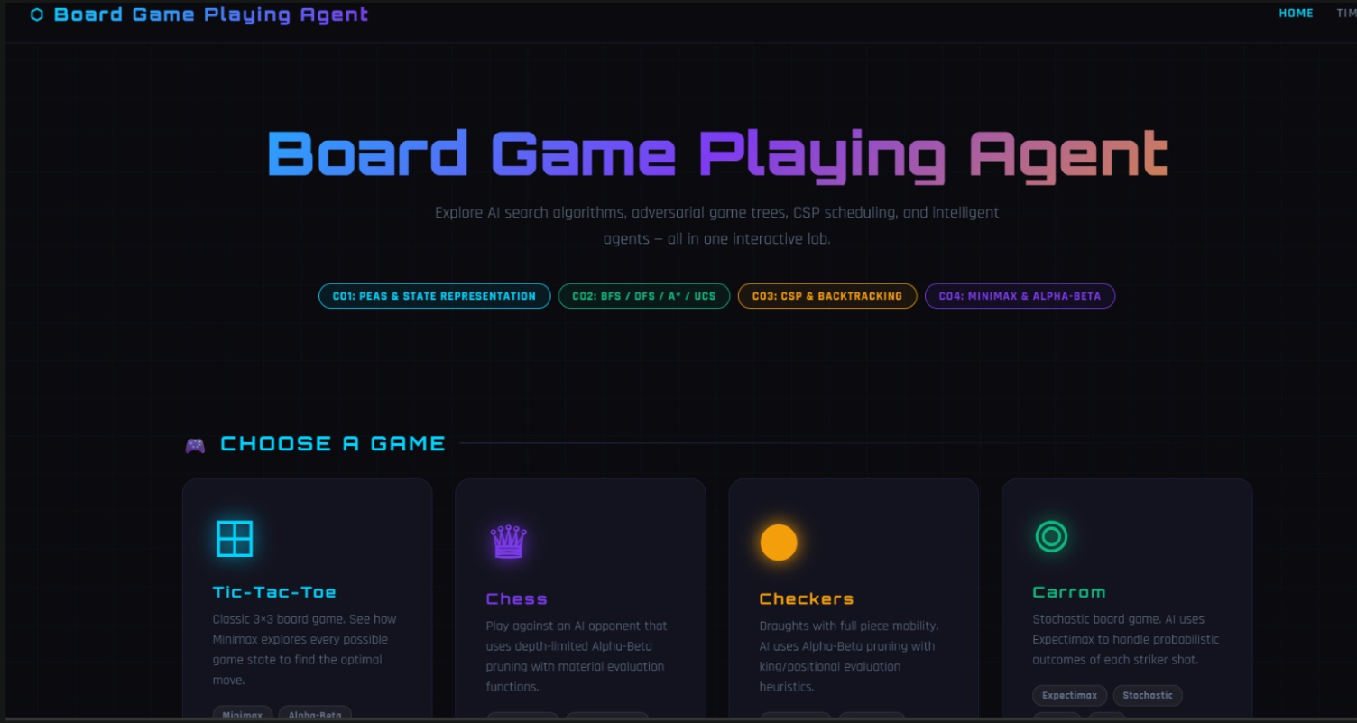

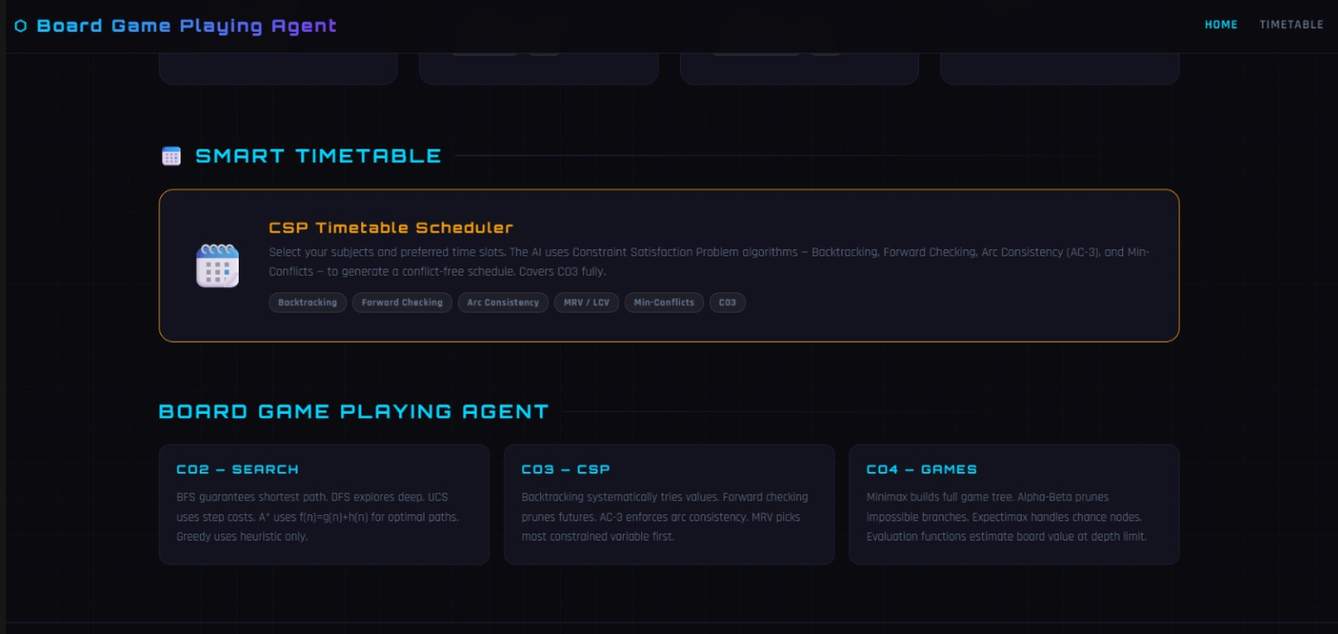
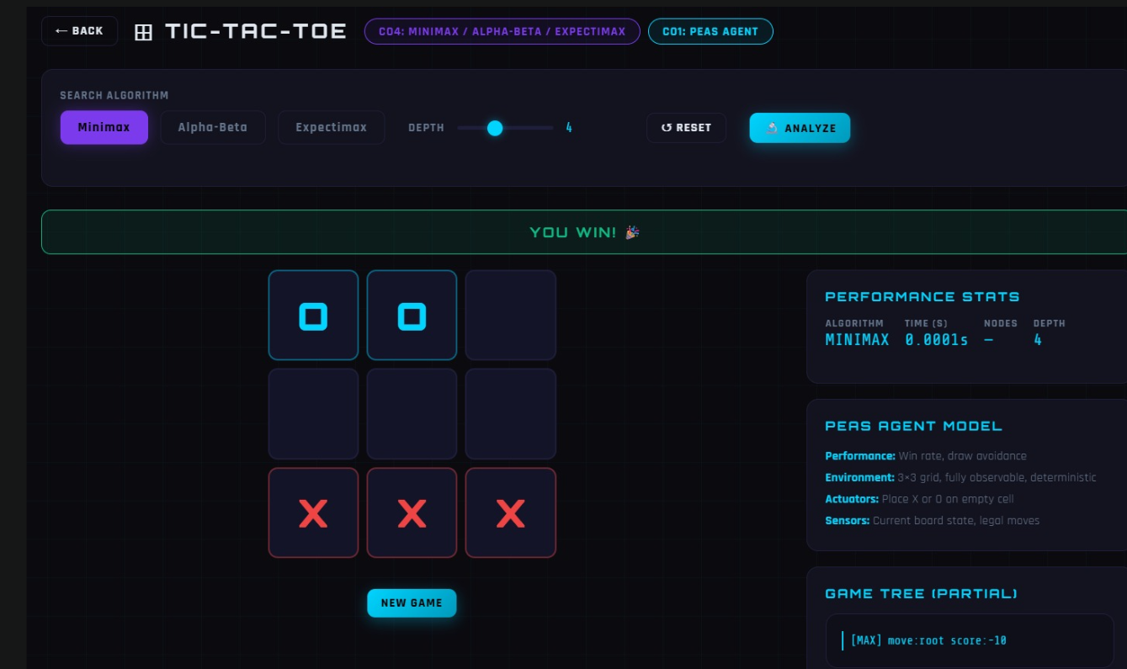

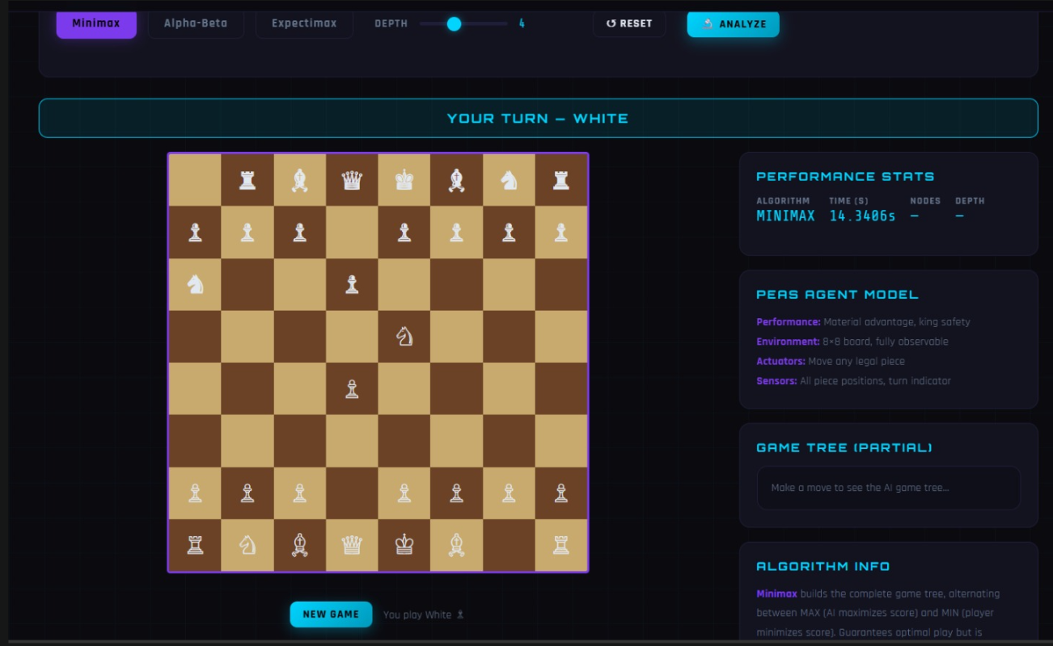
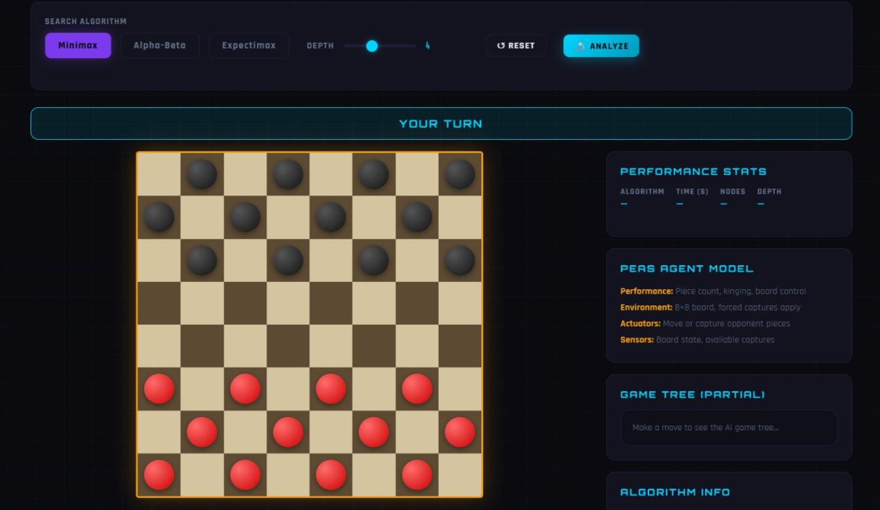
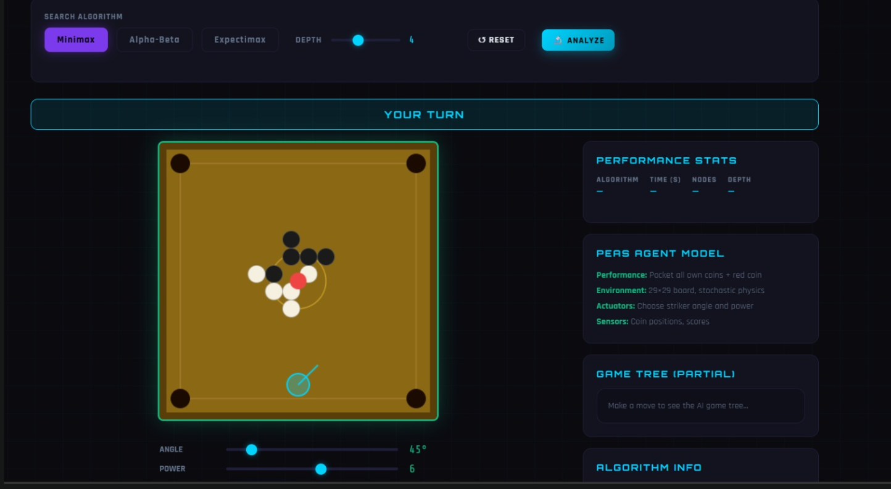

CHAPTER 5: CONCLUSION

The Board Game Playing Agent project was successfully designed and implemented using Python, Flask, HTML, CSS, and JavaScript to demonstrate the use of Artificial Intelligence in board games. The system allows the user to play games such as Tic-Tac-Toe, Chess, Checkers, and Carrom, while the AI agent makes intelligent decisions based on different search and game-playing algorithms.
In this project, important AI concepts such as BFS, DFS, UCS, Greedy Search, A* Search, Minimax, Alpha-Beta Pruning, and heuristic evaluation were studied and applied. For simpler move generation and state exploration, search algorithms were used, while for competitive decision-making in adversarial games, Minimax and Alpha-Beta pruning were used to select the best possible move against the opponent.
The project helped in understanding how an intelligent agent works by analyzing game states, generating possible moves, evaluating outcomes, and selecting optimal actions. It also provided practical knowledge of state space representation, heuristic-based search, adversarial search, and AI decision making in a real application.
Overall, the Board Game Playing Agent is a useful academic project that clearly demonstrates the implementation of AI techniques in game playing systems, and it can be further extended with stronger algorithms, better heuristics, multiplayer support, and more advanced game strategies in the future.

CHAPTER 6: REFERENCE

[1] Stuart Russell and Peter Norvig, Artificial Intelligence: A Modern Approach, 4th Edition, Pearson, 2021.
[2] David L. Poole and Alan K. Mackworth, Artificial Intelligence: Foundations of Computational Agents, Cambridge University Press, 2017.
[3] Richard E. Bellman, Dynamic Programming, Princeton University Press, 1957.
[4] John von Neumann and Oskar Morgenstern, Theory of Games and Economic Behavior, Princeton University Press, 1944.
[5] Donald E. Knuth, The Art of Computer Programming, Volume 1: Fundamental Algorithms, Addison-Wesley, 2011.
[6] Flask Documentation. Available: https://flask.palletsprojects.com/
[7] Python Software Foundation, Python Documentation. Available: https://docs.python.org/3/
[8] NumPy Developers, NumPy Documentation. Available: https://numpy.org/doc/
[9] Pandas Development Team, Pandas Documentation. Available: https://pandas.pydata.org/docs/
[10] Course Material: Computational Foundations for AI / Artificial Intelligence Laboratory, Department of Computer Science and Engineering, K L University.

